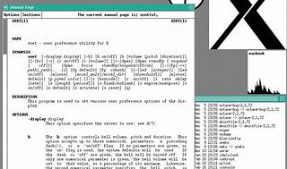

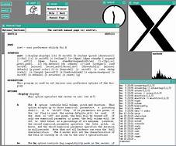

Explore

Certainly! In the realm of technology, a **shell** is a software program that acts as an interface between users (or other programs) and the operating system. [It allows users to issue commands, which it then interprets and passes on to the operating system for execution1](https://www.tech.gov.sg/media/technews/new-year-new-tech-skills)[2](https://www.ituonline.com/blogs/free-it-training-courses-online/)[3](https://www.cio.com/article/221812/8-free-online-course-sites-for-growing-your-tech-skills.html)[4](https://en.wikipedia.org/wiki/Shell_%28computing%29).

Here are **five free tech learning resources** where you can enhance your knowledge:

1. **AI Singapore Student Outreach Programme**: This initiative promotes AI literacy and proficiency among students. It offers three levels, equipping participants with programming skills and practical experience in AI projects. [Completion of each level earns an industry-recognized certificate, and level three participants receive the Google professional machine learning engineer certificate1](https://www.tech.gov.sg/media/technews/new-year-new-tech-skills).
2. **SkillsFuture@NS Learning eXperience Platform**: Designed for full-time national servicemen (NSFs), this platform provides free unlimited access to over 75,000 online courses across various categories. Skills include Python programming, machine learning, management training, and digital photography. [Some courses can even be used for credit exemptions at institutes of higher learning1](https://www.tech.gov.sg/media/technews/new-year-new-tech-skills).
3. **Coursera**: Coursera offers numerous courses for free, including offerings from renowned universities. Learn about machine learning, game theory, COVID-19 contact tracing, microeconomics, and more. [Expand your knowledge with quality content from top institutions1](https://www.tech.gov.sg/media/technews/new-year-new-tech-skills).
4. **General Assembly**: General Assembly provides free workshops, webinars, and resources on topics like coding, data science, and design. [Their community events are valuable for skill-building and networking1](https://www.tech.gov.sg/media/technews/new-year-new-tech-skills).
5. **Explore and Expand Your Knowledge**: Beyond formal courses, explore blogs, forums, and tutorials. [Websites like Stack Overflow, GitHub, and DataCamp offer valuable insights and practical learning opportunities1](https://www.tech.gov.sg/media/technews/new-year-new-tech-skills).

Remember, these resources can help you build a strong foundation in tech without spending a dime. Happy learning! 🚀